Go to SE11

**In this example, all fields are based on Data Element.**

**The Data Element is based on Built-in Type.**

1. Create table with the name as ZXXXXXXDEPT1.
2. Give delivery class as A and Display/Maintenance Allowed.
3. For the field MANDT, give data element as MANDT
4. For Field, Deptno, mention Data Element as ZXXXXXXDEDEPTNO.

Where XXXXXX is your empcode.

1. Double click on the data element ZXXXXXXDEDEPTNO.

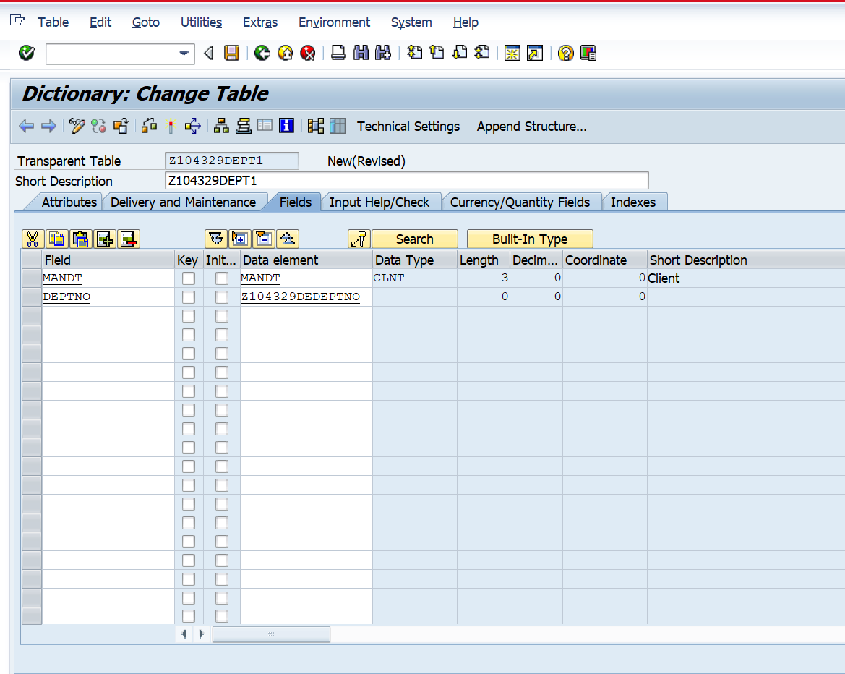

1. The following dialog box is displayed, click yes.

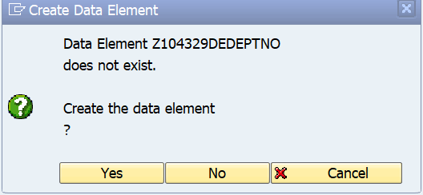

1. The data Element is based on Build-in type. Select data type and length as shown below.

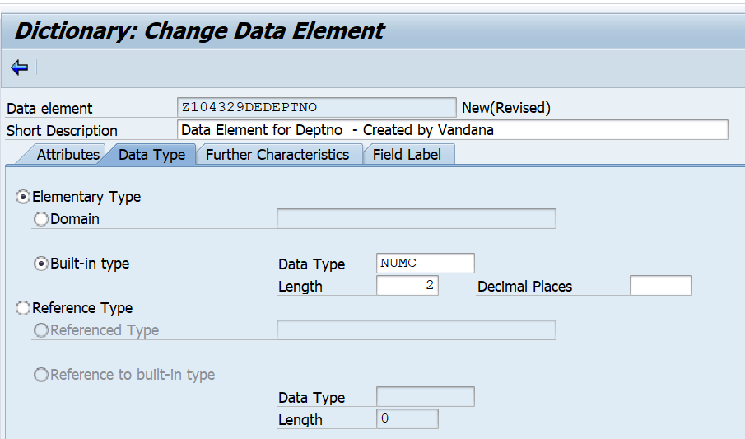

1. Enter Field Labels as shown below.

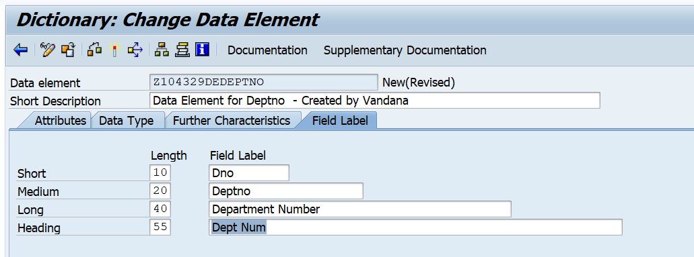

1. Click on documentation. Enter documentation as shown below.

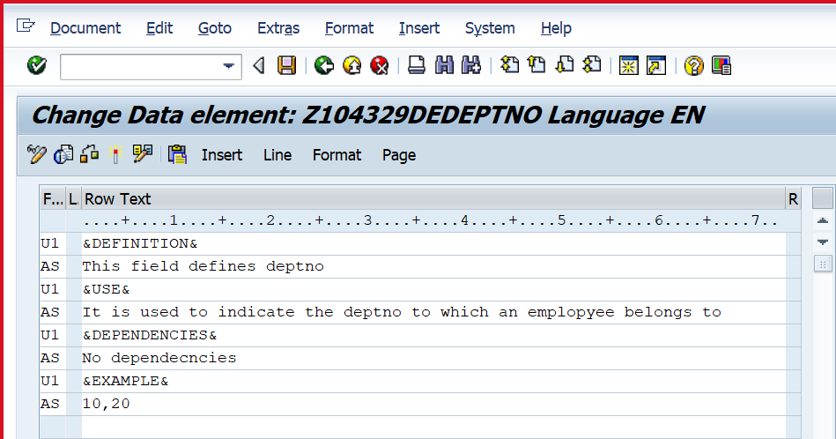

1. Save. Go back.
2. Activate the Data Element.
3. Go back. You will see screen as below which shows that the data element has been created.

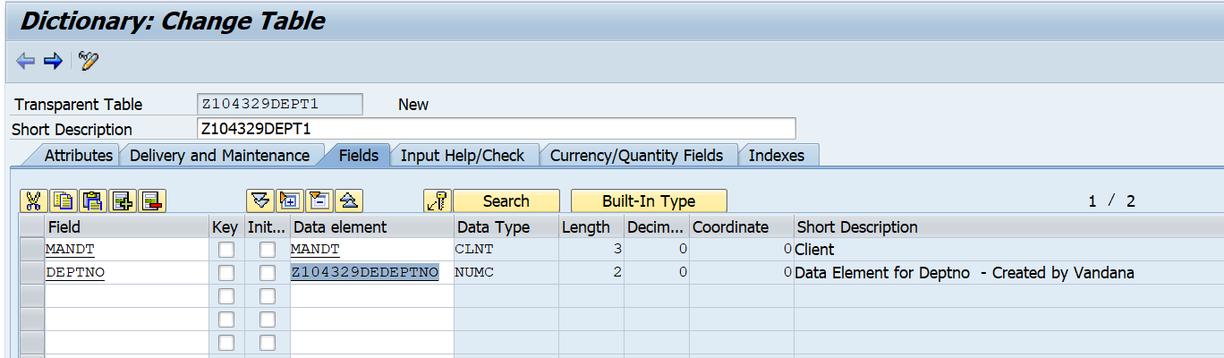

1. Similarly create the remaining two fields as shown below with appropriate field labels and documentation.
2. Give Primary keys, as shown below. Give the technical settings.
3. Save and Activate the table.

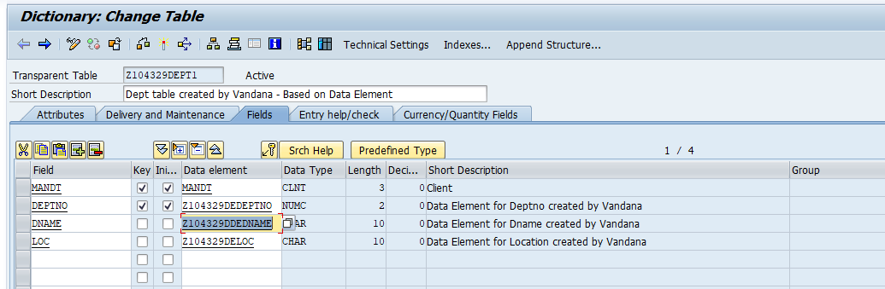

**Additional steps for reference, if required.**

**These are to enter field labels for Dname and Loc.**

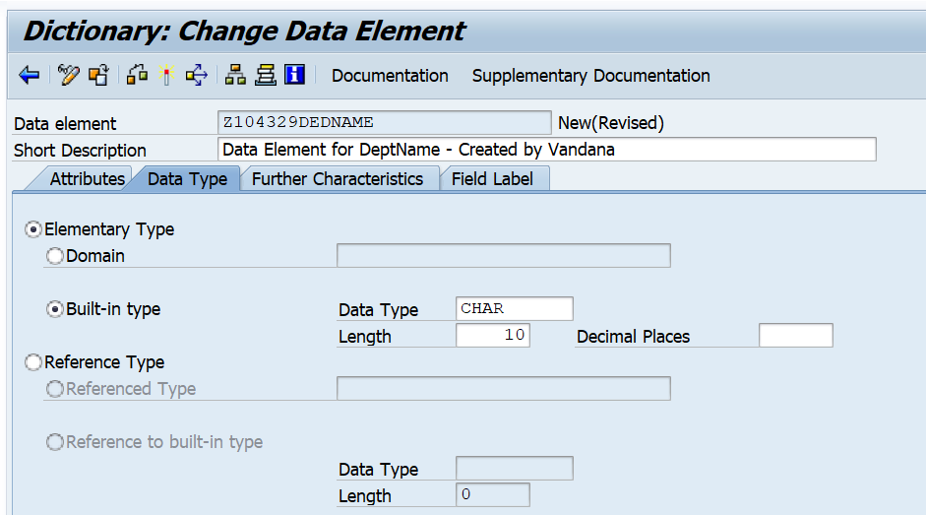

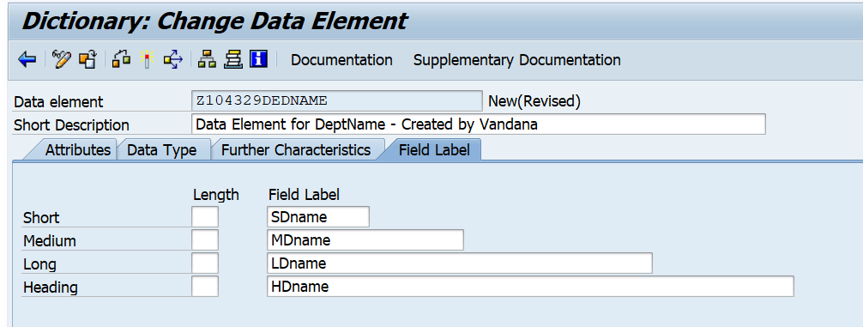

Save and Activate the above data element. Go back.

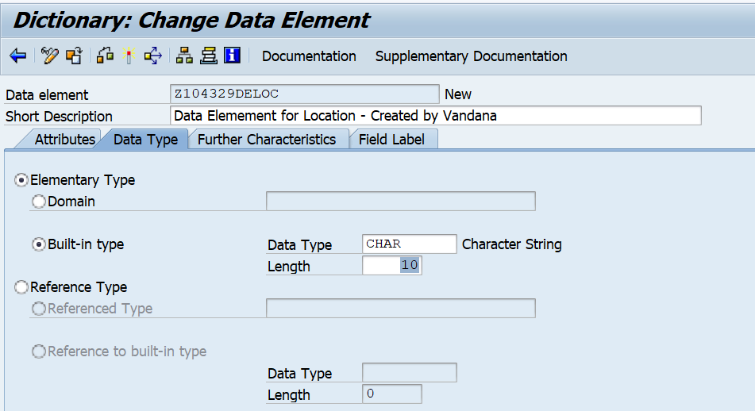

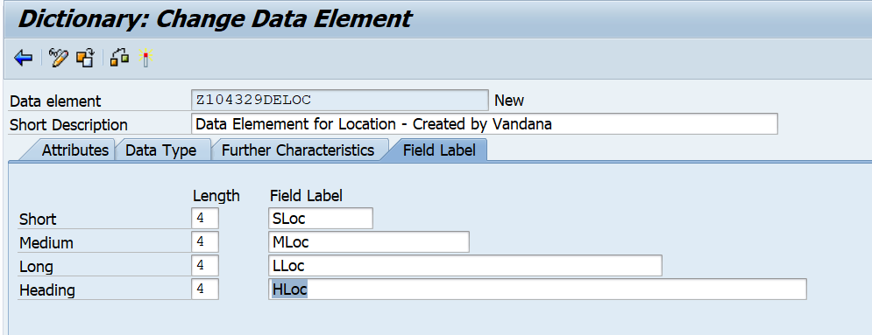

Save and Activate the above data element. Go back.

Add Records as below.

